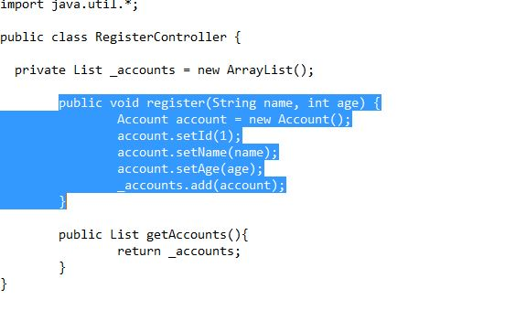**Quiz#4 (Draw Sequence diagram)**

**Solution:**

